Name: Garima Neupane
Roll Number: CSIT2081045
Subject: Statistics II, Lab Q8 (B.Sc.CSIT III Sem)
Section: ‘A’

Working Expression:
t = 𝐦𝐞𝐚𝐧 𝐨𝐟 𝐟𝐢𝐫𝐬𝐭 𝐬𝐚𝐦𝐩𝐥𝐞 – 𝐦𝐞𝐚𝐧 𝐨𝐟 𝐬𝐞𝐜𝐨𝐧𝐝 𝐬𝐚𝐦𝐩𝐥𝐞
𝐬𝐭𝐚𝐧𝐝𝐚𝐫𝐝 𝐞𝐫𝐫𝐨𝐫

Working Procedure:
Define variables in variable view → put value company 1 and company 2 (string) → go to analyze → compare means → independent sample t –test → put values of company in test variables and company in grouping variable → go to options give level of confidence 95% → continue → ok

SPSS OUTPUT:
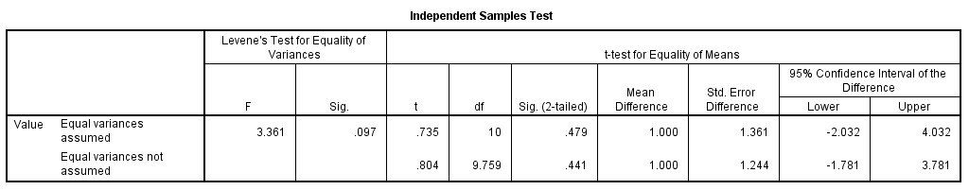

Setting of Hypothesis:
Ho: There is no significant difference in the durability of RAM produced by company A and company B.
H1: There is significant difference between in the durability of RAM produced by company A and company B. (two tailed test)

For Levene’s test for equality of variances, p- value = 0.097 > α = 0.05, we accept Ho Hence, equal variances assumed.

Decision:
Since 2p = 0.479 > α = 0.05, we accept Ho.
Conclusion:
We conclude that there is no significant difference in the durability of RAM produced by company A and company B.

